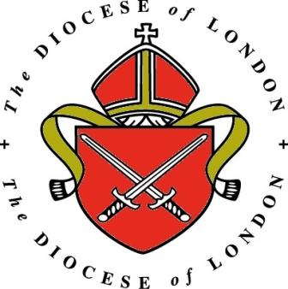 | Central London  Pastoral Assistants Scheme  2023 - 2024
Application for
Pastoral Assistant 2023 - 2024

Name

Address

Telephone

Email

Age |  | Marital status

Home church

Diocese

Please provide some information about your vocation if relevant
(contact with DDO, ABM etc.)

Education / work

What are your main strengths?

- and weaknesses?

What interests you about St Dunstan’s and this post ?

Only St Dunstan’s is recruiting this year
St Matthew’s |  | St Peter’s |  | St Dunstan’s | X

 | Central London  Pastoral Assistants Scheme 2023 - 2024 | St Matthew’s  Westminster

Parish Assistant Appointments 2023 - 2024

Please provide the names of three people willing to provide a reference
(one of whom should be a priest). It would be very helpful to have email addresses and phone numbers for your referees.

1

2

3

How did you hear about this post?

Please return this form, with a passport sized photograph, electronically to
rector@stdunstanstepney.com

The deadline for applications is Wednesday 12th July 2023 at 5pm
Interviews will be arranged after the closing date

